**实验十三：计数器/定时器设计与应用**

|  |  |  |  |  |  |  |  |  |
| --- | --- | --- | --- | --- | --- | --- | --- | --- |
| 姓名： | 钱旭峰 | | 学号： | 3140102491 | | 专业： | | 计算机科学与技术 |
| 课程名称： | | 逻辑与计算机设计基础实验 | | | 同组学生姓名： | | 於航 | | |
| 实验时间： | 2015-12-周三 | | 实验地点： | 紫金港东4-509 | | 指导老师： | | 蒋方炎，王总辉 |

**设计工程一：Exp130-WallClock**

1：用verilog设计实现毫秒计数器

module millisecond(

input clk,

input reset,

output clk_1ms

);

parameter COUNTER=16;

reg [COUNTER-1:0]count;

reg second_m;

initial count<=0;

always@(posedge clk)

begin

if(!reset||(count[COUNTER-1:0]==49999))

begin

count[COUNTER-1:0]<=0;

second_m<=1;

end

else

begin

count[COUNTER-1:0]<=count+1;

second_m<=0;

end

end

assign clk_1ms=second_m;

Endmodule

以毫秒计数器为依据，设计秒计数器：

module clk_1ms(

input clk,

input reset,

output reg clk_1s,

output [11:0] msecond

);

reg [11:0] mss;

initial begin

mss <=0;

end

assign msecond=mss;

always@(posedge clk)

begin

if(!reset)

begin

mss<=0;

clk_1s<=0;

end

else if(mss==12'b100110011001)

begin

mss<=0;

clk_1s<=1;

end

else if(mss[7:0]==8'b10011001)

begin

mss[7:0]<=0;

mss[11:8]<=mss[11:8]+1;

end

else if(mss[3:0]==4'b1001)

begin

mss[3:0]<=0;

mss[7:4]<=mss[7:4]+1;

end

else

begin

mss[3:0]<=mss[3:0]+1;

clk_1s<=0;

end

end

endmodule

**再以秒计数器为依据，设计count_60,来实现分和小时**

module count_60(

input clk,

input reset,

output reg [7:0] six_ten,

output reg count_carry

);

initial

begin

six_ten<=8'b00000000;

count_carry<=0;

end

always@(posedge clk)

begin

if(!reset)

begin

six_ten<=8'b00000000;

count_carry<=0;

end

if(six_ten==8'b01011001)

begin

six_ten<=8'b00000000;

count_carry<=1;

end

else if(six_ten[3:0]==4'b1001)

begin

six_ten[3:0]<=4'b0000;

six_ten[7:4]<=six_ten[7:4]+1;

end

else

begin

six_ten<=six_ten+1;

count_carry<=0;

end

end

Endmodule

最后设计天计数器：即count_24

module count_hour(

input clk,

input reset,

output reg [7:0] hour,

output reg count_carry

);

initial

begin

hour<=8'b00000000;

count_carry<=0;

end

always@(posedge clk)

begin

if(!reset)

begin

hour<=8'b00000000;

count_carry<=0;

end

if(hour==8'b00100100)

begin

hour<=8'b00000000;

count_carry<=1;

end

else if(hour[3:0]==4'b1001)

begin

hour[3:0]<=4'b0000;

hour[7:4]<=hour[7:4]+1;

count_carry<=0;

end

else

begin

hour<=hour-1;

count_carry<=0;

end

end

Endmodule

最后合成wall_clock模块（见附件）

最后加入顶层模块：

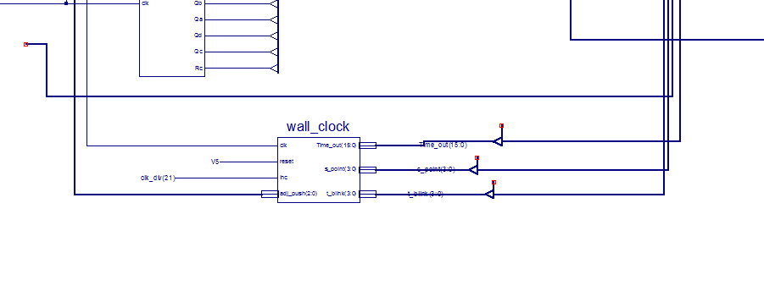

下板之后结果见视频